
TOPIC: ADVANCED WEB(BIT3208)

NAME: HARRISON MUTUA

ADMISSION: BSCCS/2024/54032

COURSE: BACHELOR OF SCIENCE IN INFORMATION TECHNOLOGY

DEPARTMENT: COMPUTING AND INFORMATICS

LECTURER: Michael Nyoro

Project Details

TITLE: Boma Homes Tenant and Landlord Management System

STACK
HTML, PHP, MySQL and JavaScript
Server; XAMPP

GitHub link: https://github.com/HARRISON-MUTUA/BIT3208-ADVANCED-WEB-DESIGNING-AND-DEVELOPMENT.BomaHomes.git

Table of Contents
Week 1 Local Environment Setup 5
Student Reflection 5
Figures 5
Fig 1: Installation of XAMMP 5
Fig 2: Apache and MySQL running 6
Fig 3: Localhost running 6
Fig 4: Hello World test 7
Fig 5: Database Connection Test 7
Fig 6: Folder structure 7
Week 2 Wire frames and GUI Designs 8
Student Reflection 8
Figures 8
Fig 2: Login Layout Design 10
Fig 3: Dashboard layout Design 11
Fig 4: Navigation Structure 12
Fig 5: Mobile View Mock up 13
Fig 6: GUI Prototype 15
Week 3 JavaScript and PHP BASICS 15
Student Reflection 15
Figures 15
Fig 1: JavaScript form validation 15
Fig 2: Password strength checker 17
Fig 3:PHP Syntax practice 18
Fig 4: Database Connection Script 18
Fig 5: Dynamic User Input Handling 19
Fig 6: Folder Structure 19
Week 4 Server-Side Components and Backend Foundations 19
Student Reflection 19
Figures 19
Fig 1: User Registration Form 20
Fig 2: Login Form 21
Fig 3: Dashboard 22
Fig 4: Session Handling Test 22
Fig 5: Folder structure 23
Week 5 Database Components and CRUD Operations 23
Student Reflection 23
Figures 23
Fig 1: Tenant Registration Form 24
Fig 2: Viewing Tenants Records 25
Fig 3: Updating Tenant Information 26
Fig 4: Deleting Tenant Records 26
Fig 5: MySQL database tables 27
Fig 6: folder structure 28
Week 6 Database Integration and CRUD Operations 28
Student reflection 28
Figures 29
Fig1: Database creation 29
Fig 2: add tenant form 30
Fig 3: View Tenants 30
Fig 4: Edit Tenant 31
Fig 5: Delete Tenant 31
Fig 6: View messages 32
Fig 7: folder structure 32
Week 7 user authentication and session management 32
Student reflection 33
Figures 33
Fig 1: user registration form 33
Fig 2: login form 34
Fig 3: session handling 35
Fig 4: logout functionality 35
Fig 5: folder structure 35
Week 8 Responsive Web Design and Mobile-First Development 36
Student reflection 36
Figures 36
Fig 1: Viewport Meta tag 36
Fig 2: Media Queries 36
Fig 3: Flexbox layout 37
Fig 4: CSS Grid layout 37
Fig 5: Responsive Dashboard 38
Fig 6: Responsive Register page 39
Fig 7: Responsive login page 40
Fig 8: folder structure 41

Week 1 Local Environment Setup

Student Reflection
During Week 1, I successfully configured the local development environment required for the BomaHomes system. XAMPP was installed and Apache together with MySQL services were tested successfully. PHP and MySQL database connectivity was also tested using mysql connect(). This week improved my understanding of local server configuration and backend environment setup for web application development.

Figures

Fig 1: Installation of XAMMP in pc

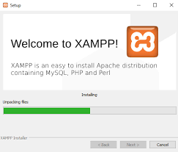

Fig 2: Apache and MySQL running
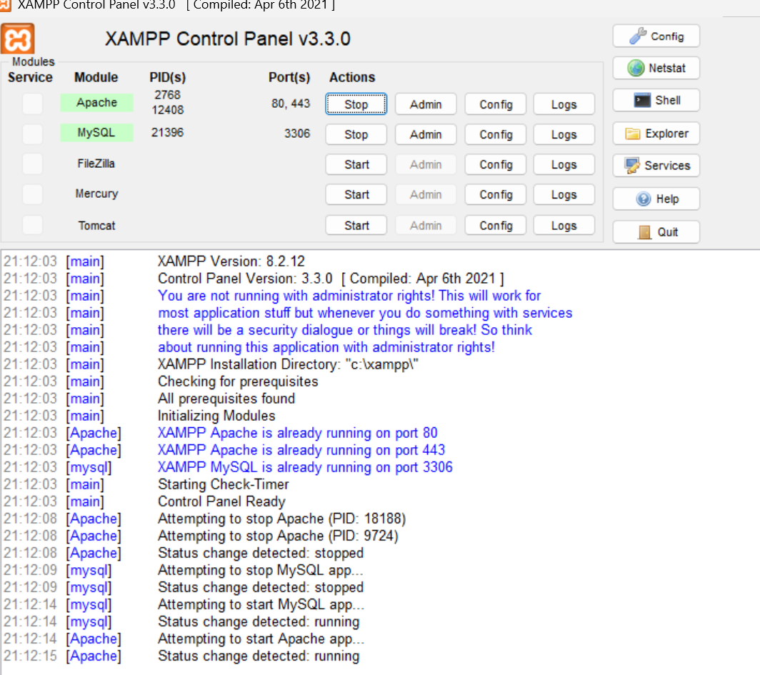

Fig 3: Localhost running
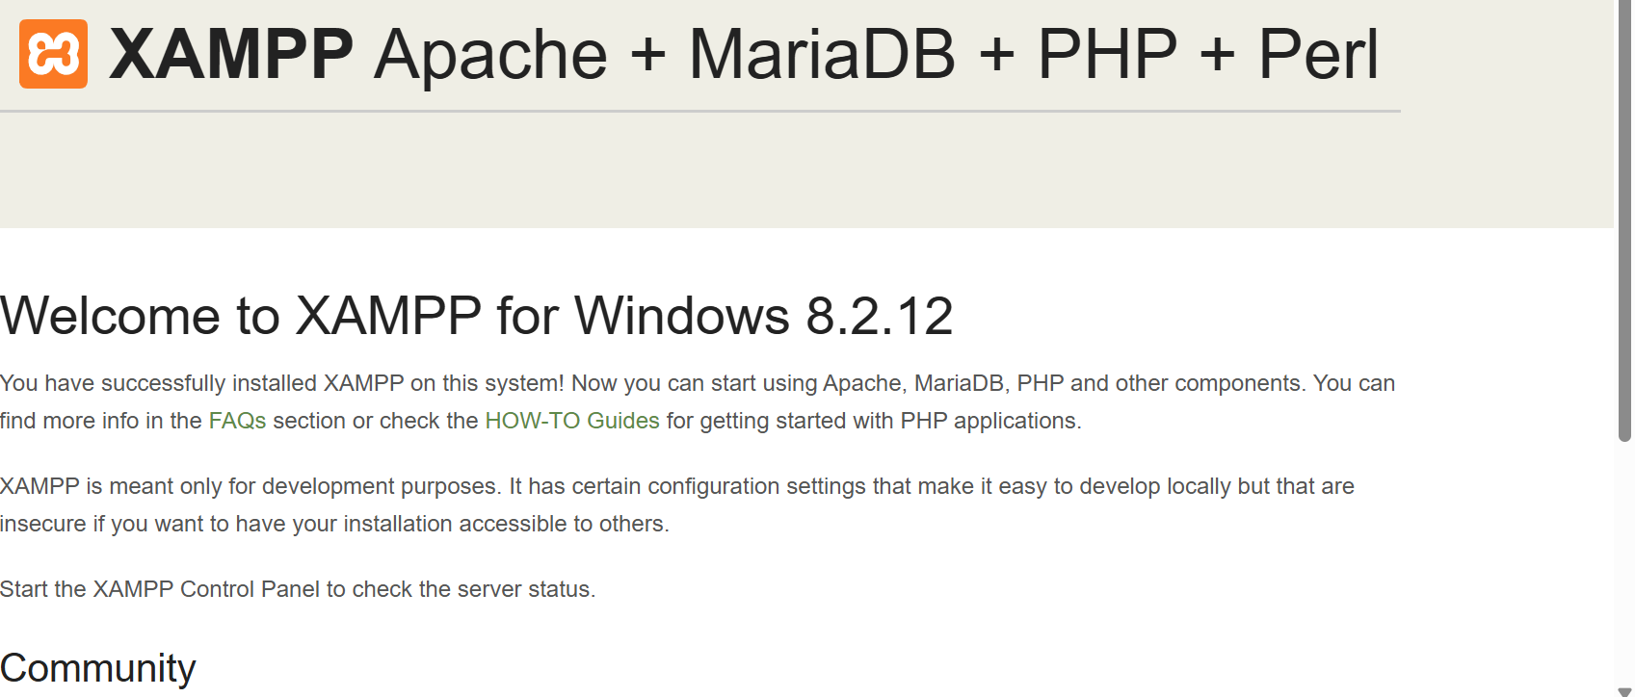

Fig 4: Hello World test
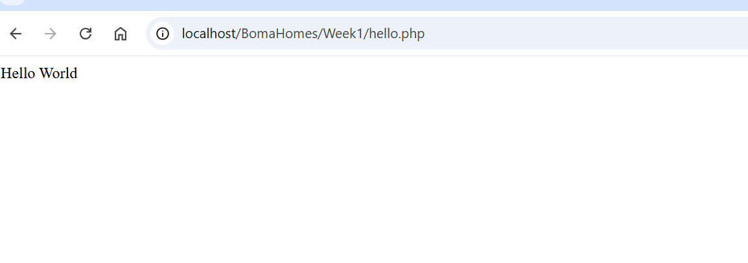

Fig 5: Database Connection Test
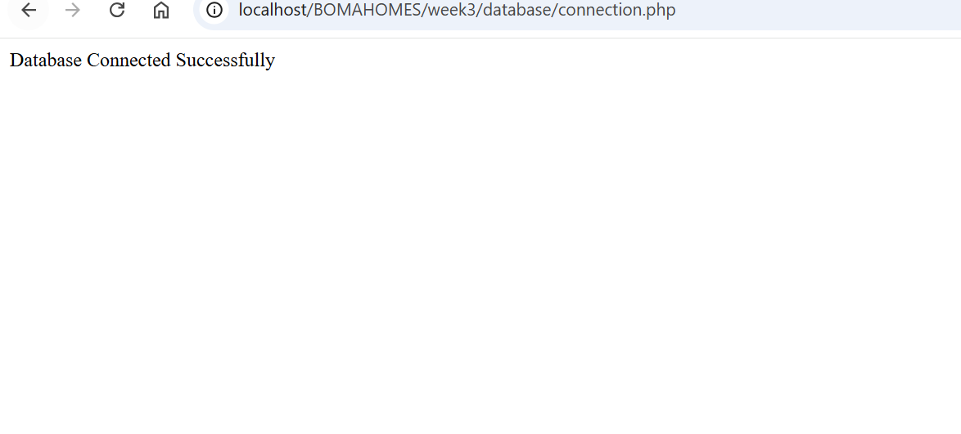

Fig 6: Folder structure
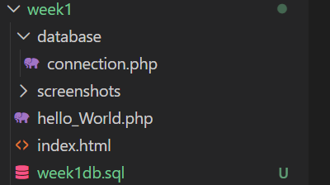

Week 2 Wire frames and GUI Designs

Student Reflection
This week, I learned the importance of planning before coding. I created wireframes for all my pages using Figma, which helped me visualize how users would interact with the system before writing any code. I also designed the GUI concepts including navigation layout, colors, buttons, forms, and mobile responsiveness.
I selected my project theme as Property Management System and chose PHP + MySQL as my technology stack. I planned the folder structure to keep my project organized.

Figures

Fig 1: Register Layout Design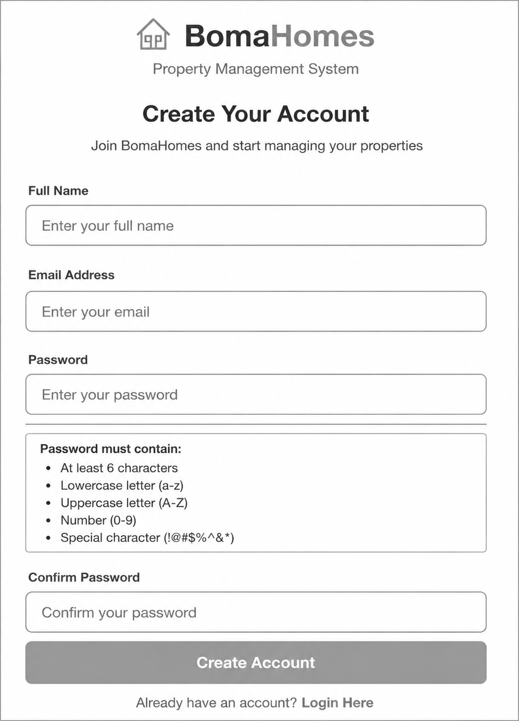

Fig 2: Login Layout Design
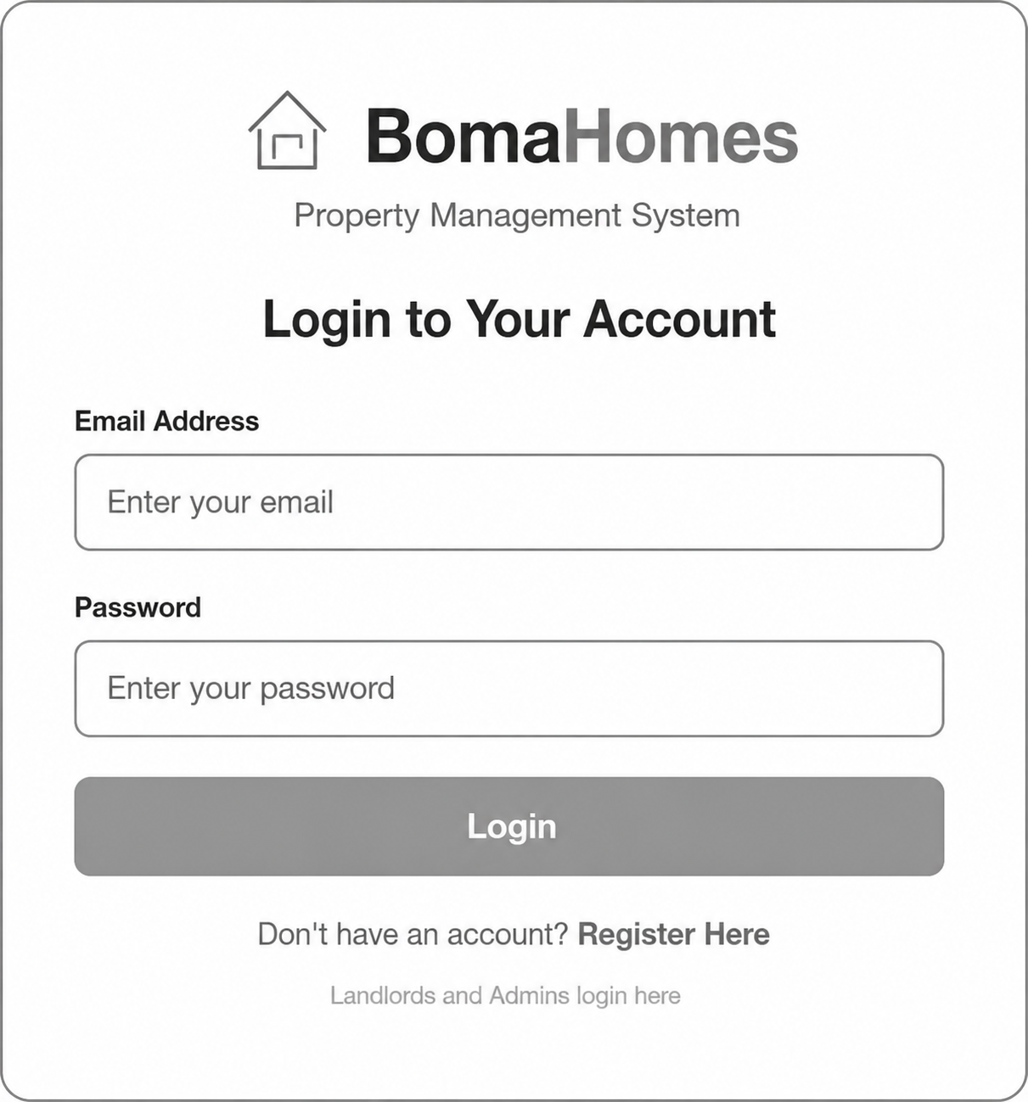

Fig 3: Dashboard layout Design
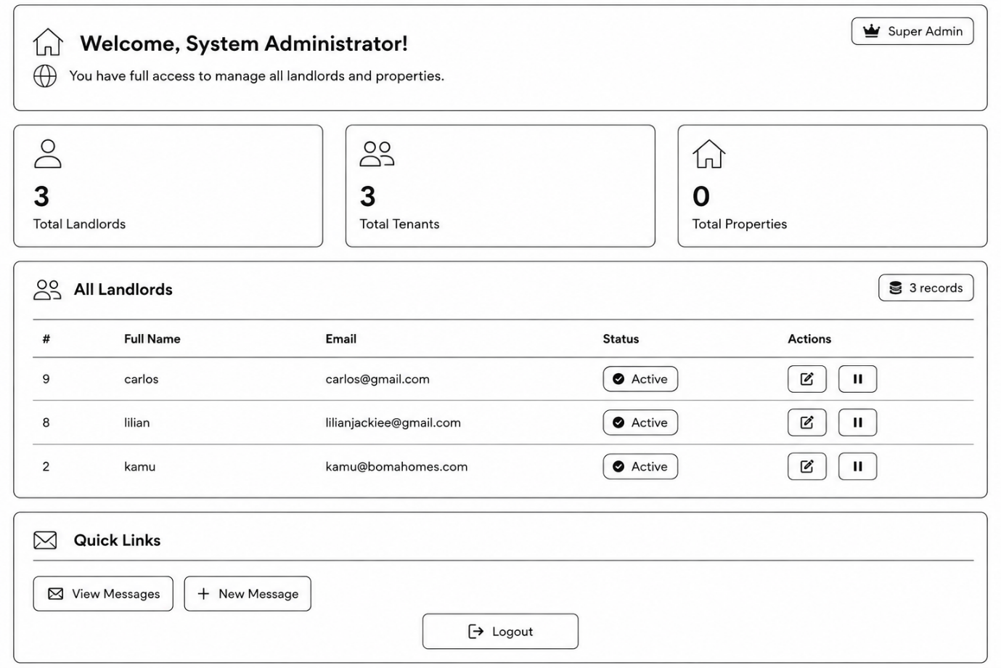

Fig 4: Navigation Structure
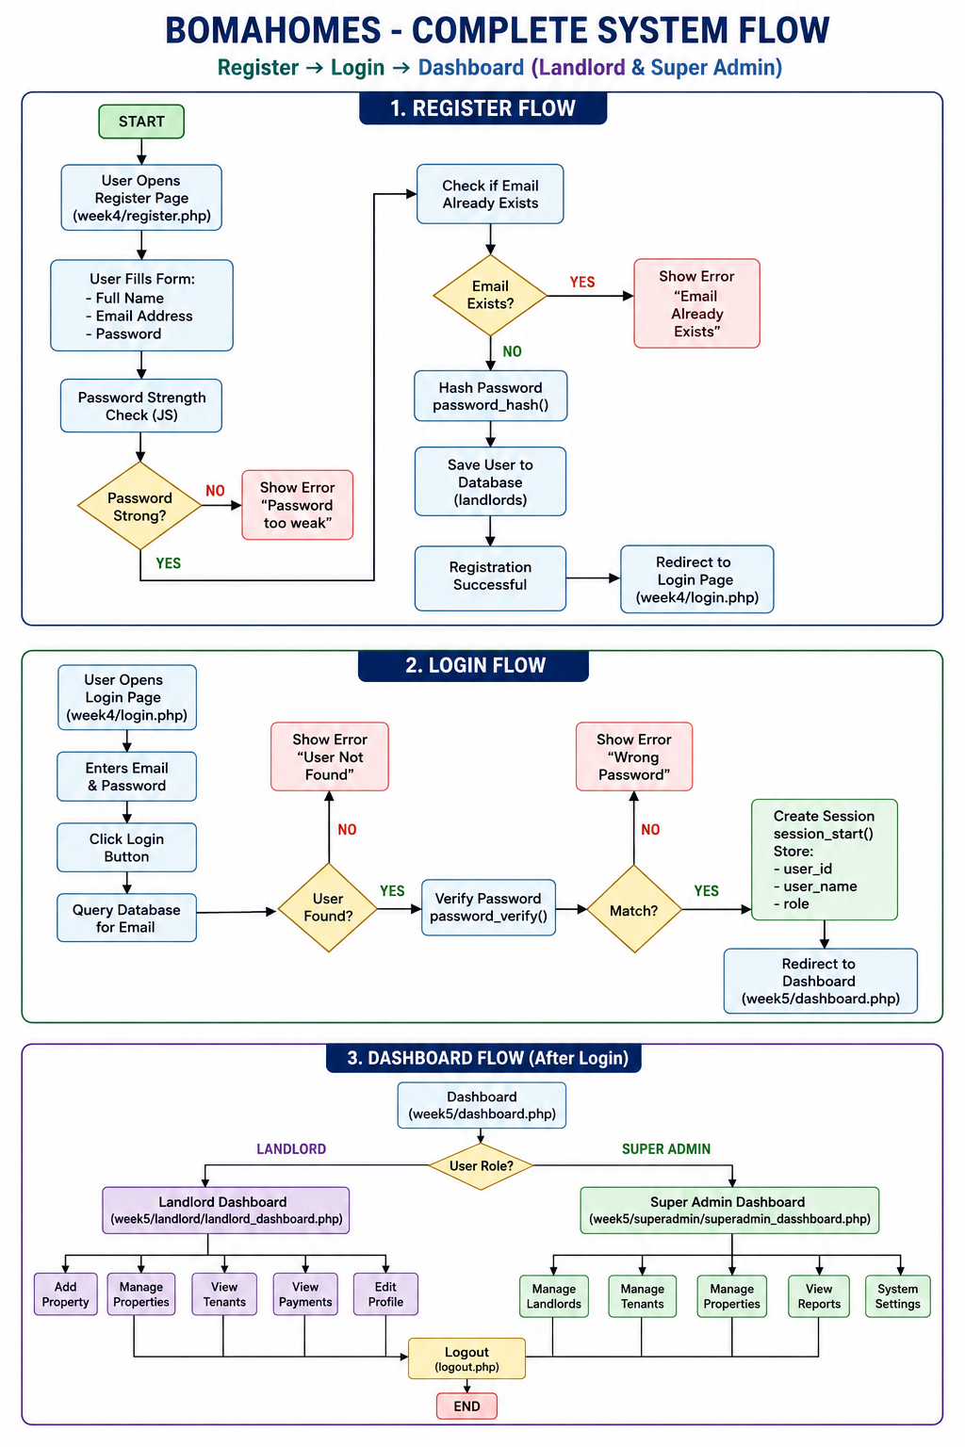

Fig 5: Mobile View Mock up

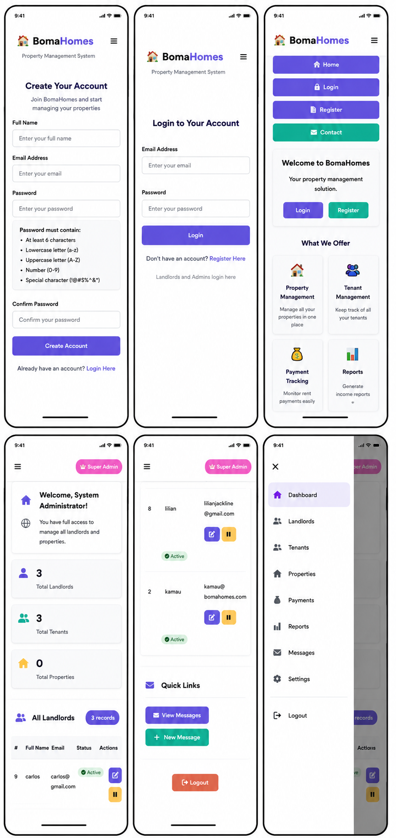

Fig 6: GUI Prototype

Week 3 JavaScript and PHP BASICS

Student Reflection
During Week 3, I implemented frontend validation and backend processing features for the BomaHomes system. JavaScript improved user interaction by validating form input before submission, while PHP handled backend processing and database connectivity. This week improved my understanding of how frontend and backend technologies interact in dynamic web applications.

Figures

Fig 1: JavaScript form validation

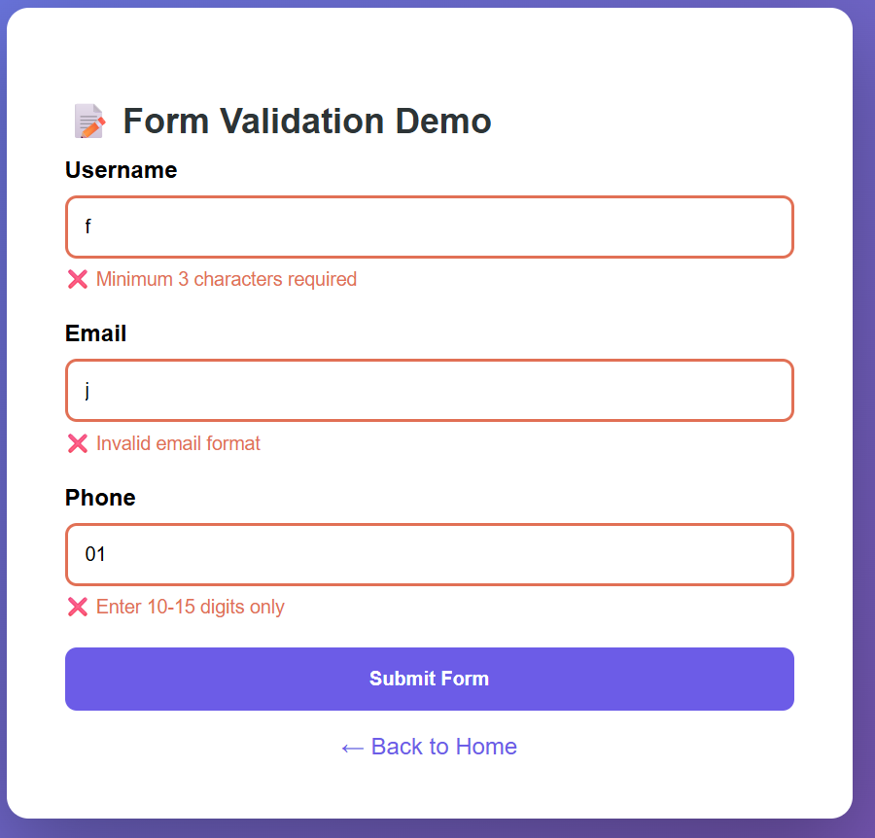
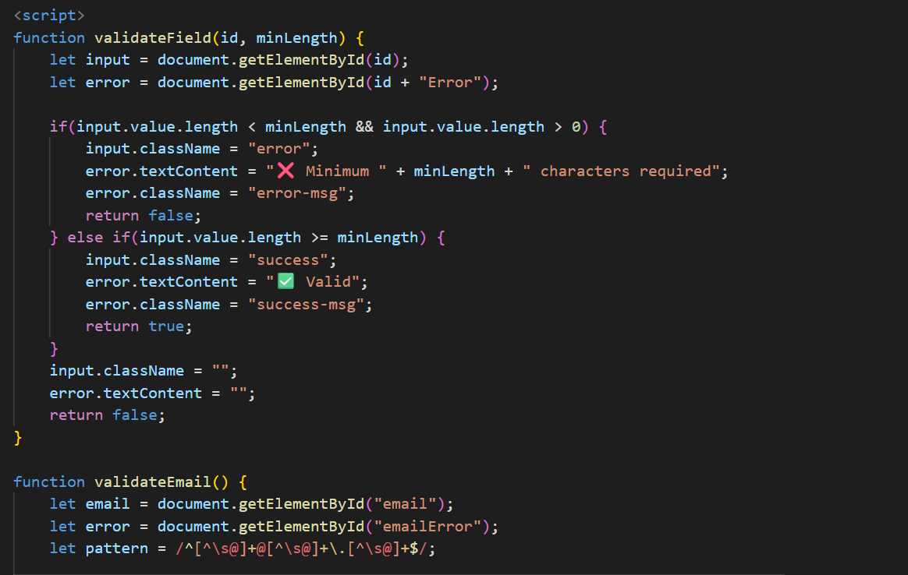

Fig 2: Password strength checker
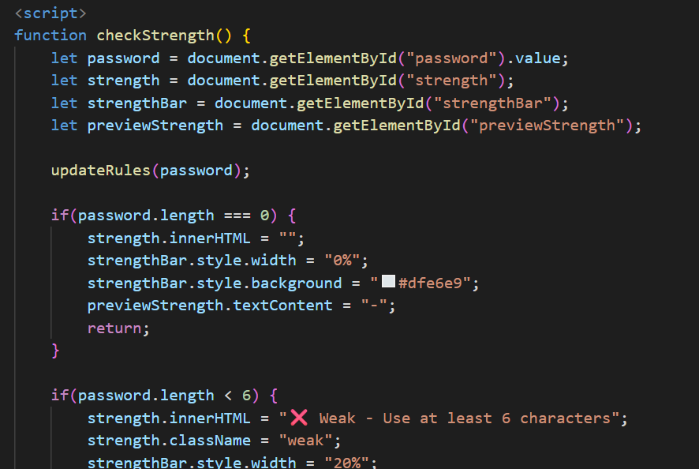

Fig 3:PHP Syntax practice

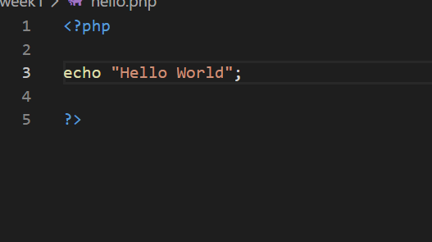
Fig3.3 shows successful execution of PHP syntax practice within the BomaHomes project.

Fig 4: Database Connection Script
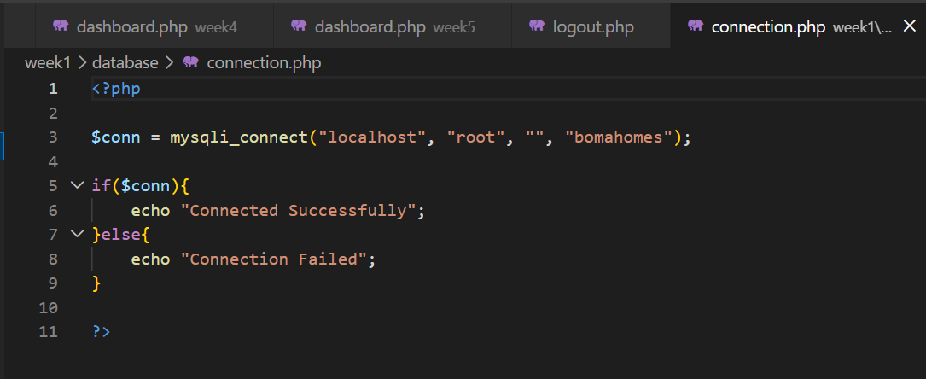

Fig 5: Dynamic User Input Handling
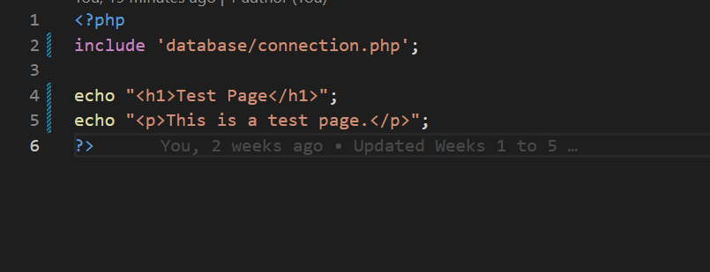

Fig 6: Folder Structure
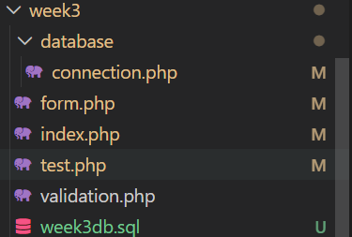

Week 4 Server-Side Components and Backend Foundations

Student Reflection
During Week 4, I implemented the authentication system for the BomaHomes project. Users can now register and login securely using PHP sessions and password hashing. Session handling was used to restrict unauthorized dashboard access. This week improved my understanding of backend authentication and secure login implementation in web applications

Figures

Fig 1: User Registration Form

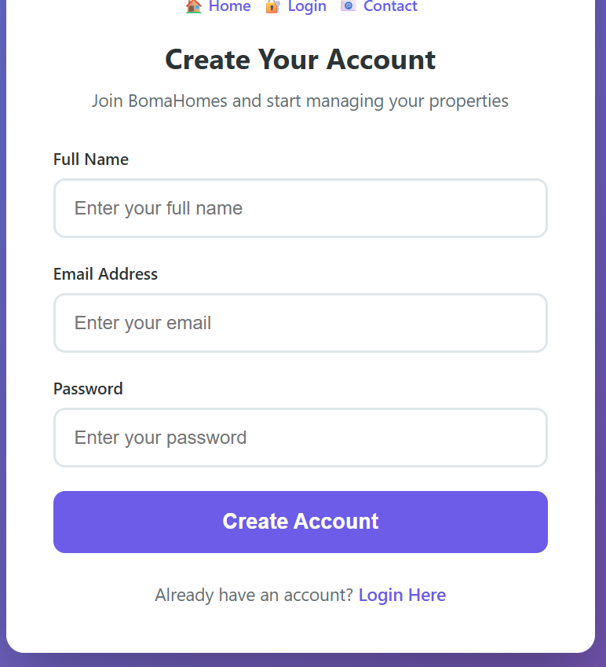

Fig 2: Login Form
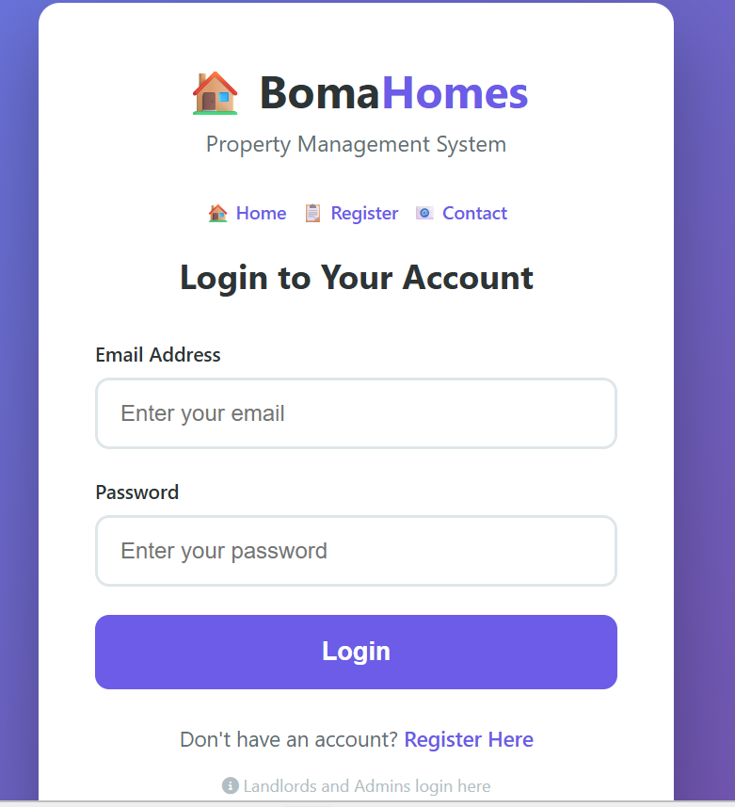

Fig 3: Dashboard
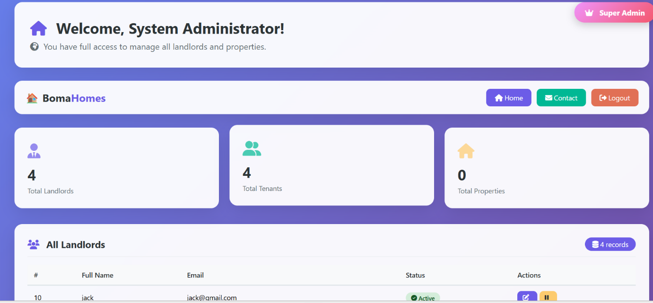

Fig 4: Session Handling Test
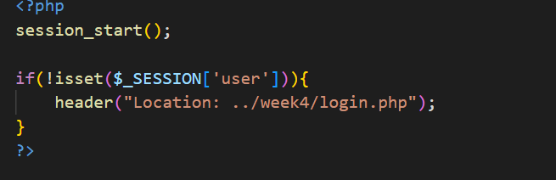
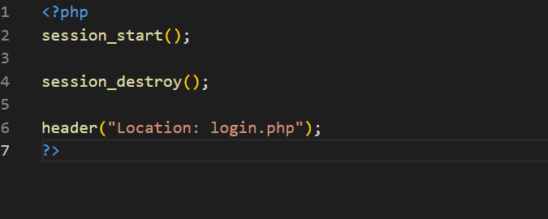

Fig 5: Folder structure
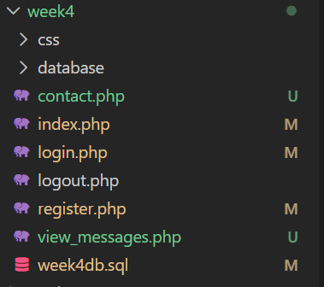

Week 5 Database Components and CRUD Operations

Student Reflection
During Week 5, I implemented CRUD operations for the BomaHomes Tenant and Landlord Management System. PHP and MySQL were integrated to allow adding, viewing, updating, and deleting tenant records dynamically. This week improved my understanding of backend-data integration and database-driven web applications.

Figures

Fig 1: Tenant Registration Form
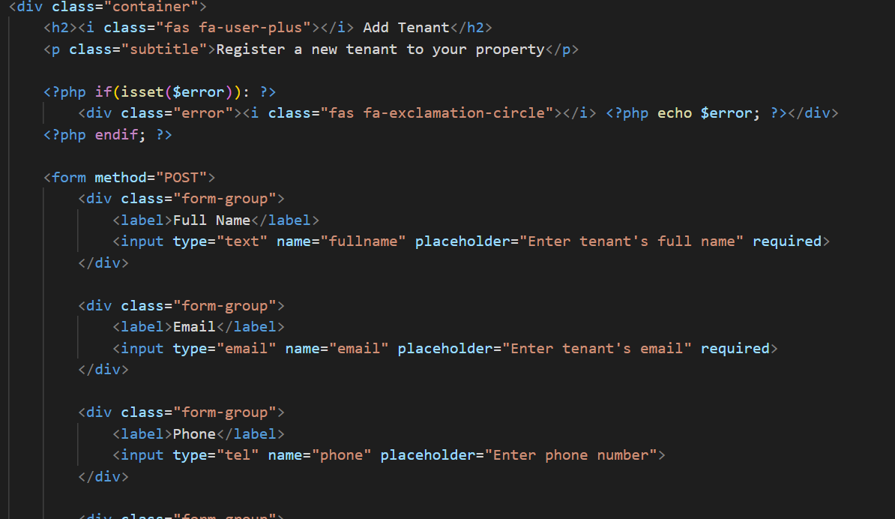

Fig 2: Viewing Tenants Records
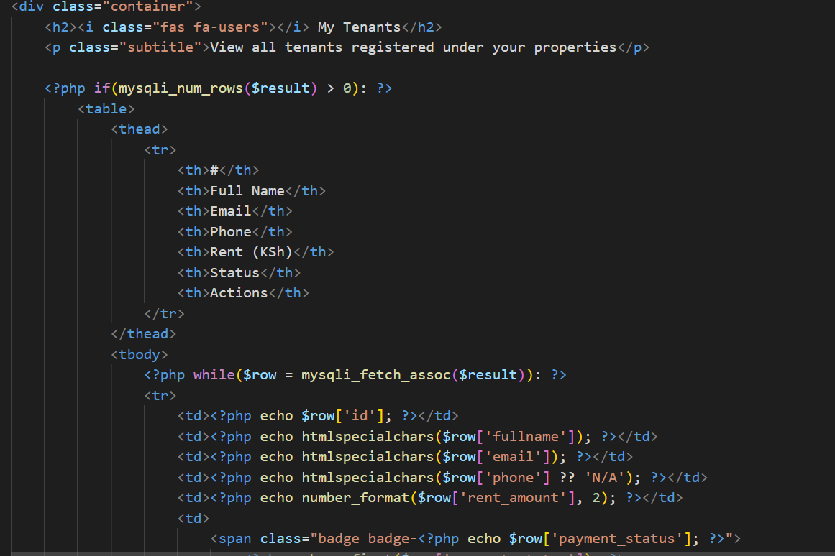

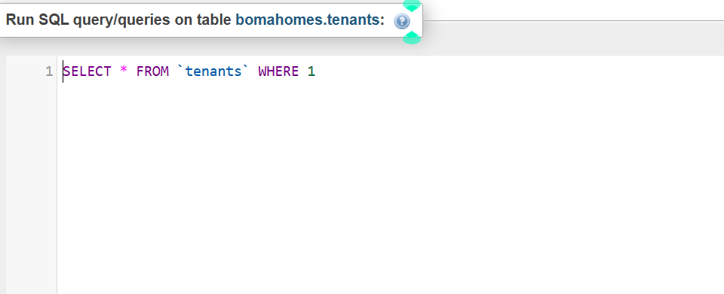

Fig 3: Updating Tenant Information
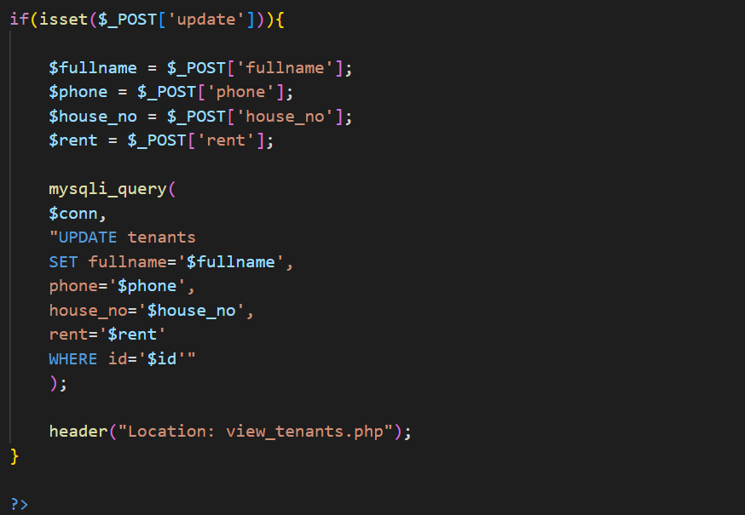

Fig 4: Deleting Tenant Records
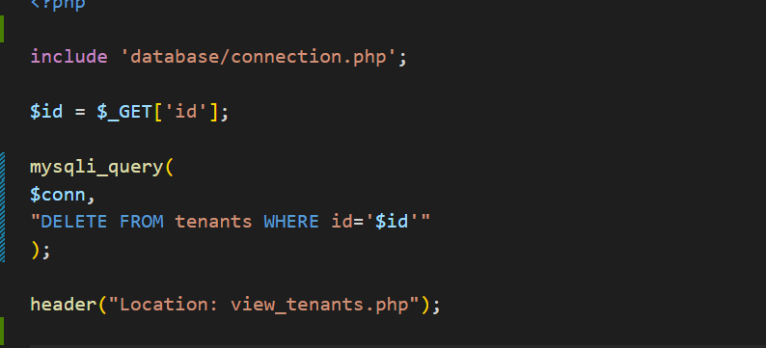
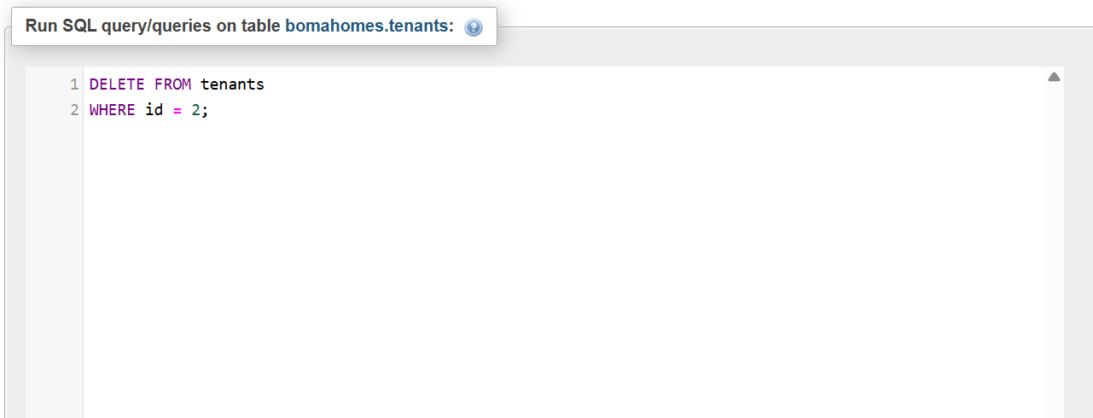

Fig 5: MySQL database tables
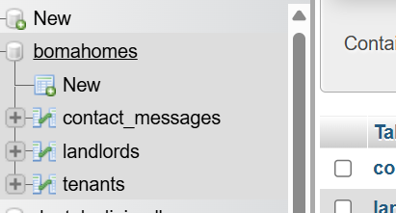

Fig 6: folder structure
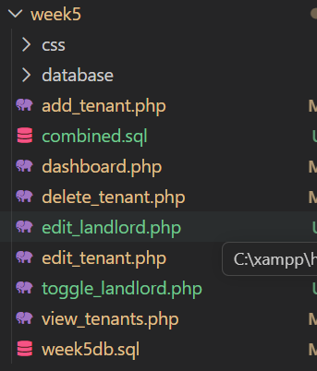

Week 6 Database Integration and CRUD Operations

Student reflection

This week I learned how to integrate a PHP application with a MySQL database and perform CRUD operations. I developed features for adding, viewing, editing, and deleting tenant records in the BomaHomes system. These activities improved my understanding of database connectivity, SQL queries, and form handling. I also learned the importance of validating user input and testing database-driven applications.

Figures

Fig1: Database creation
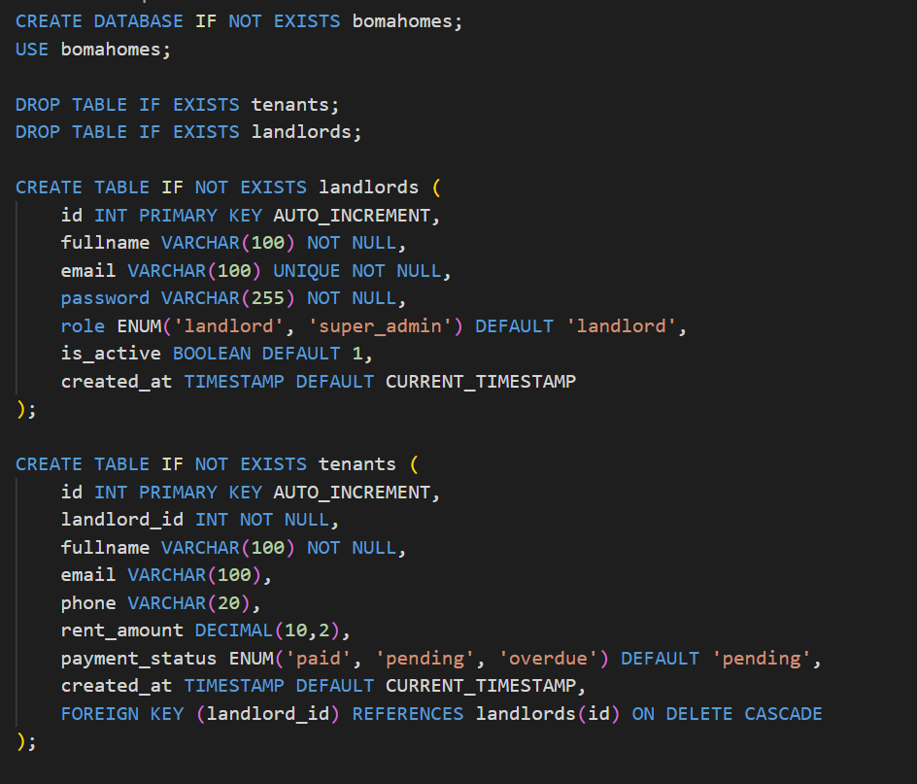

Fig 2: add tenant form

Fig 3: View Tenants

Fig 4: Edit Tenant
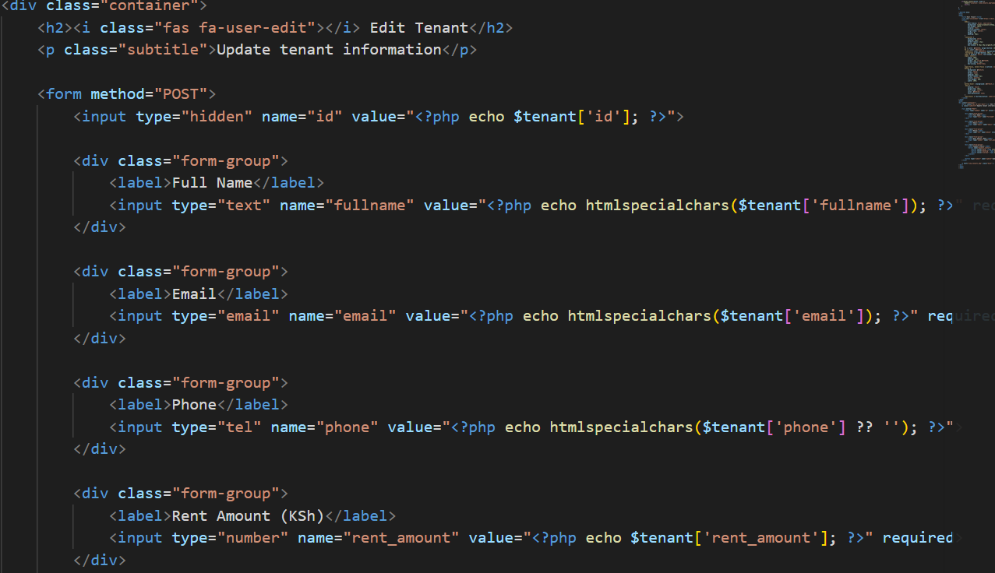

Fig 5: Delete Tenant
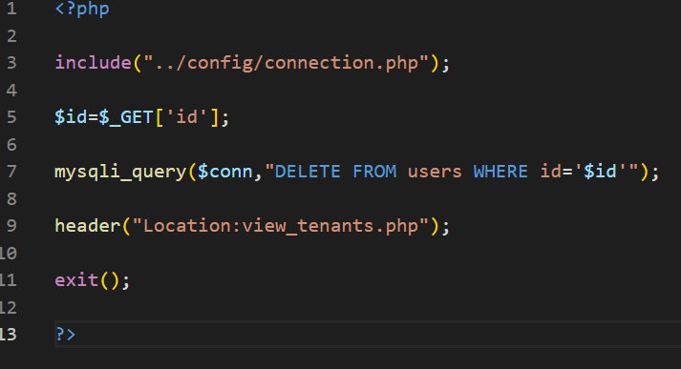

Fig 6: View messages
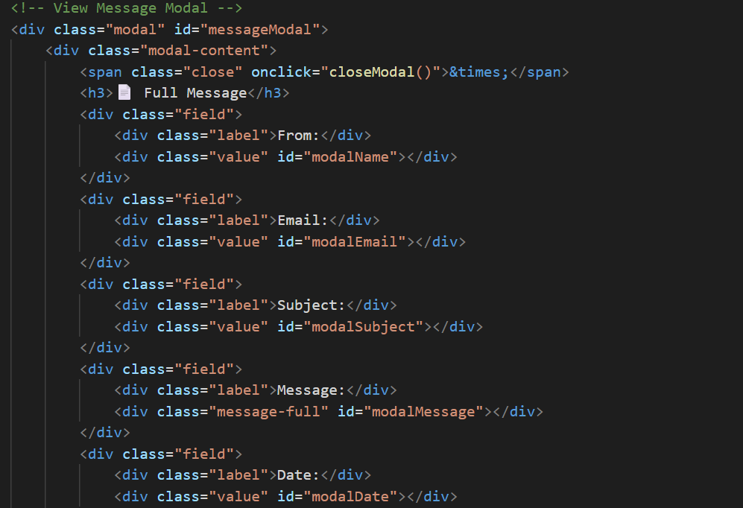

Fig 7: folder structure
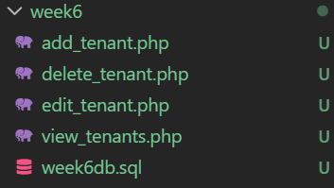

Week 7 user authentication and session management

Student reflection
This week I learned how to make websites work on all devices using responsive design. I added the viewport meta tag to control layout on mobile, used media queries to apply different styles at different screen sizes, and used Flexbox and CSS Grid to create flexible layouts. I made my dashboard, login, register, and contact pages responsive using a mobile-first approach. I tested my site on different screen sizes using Chrome DevTools.

Figures

Fig 1: user registration form
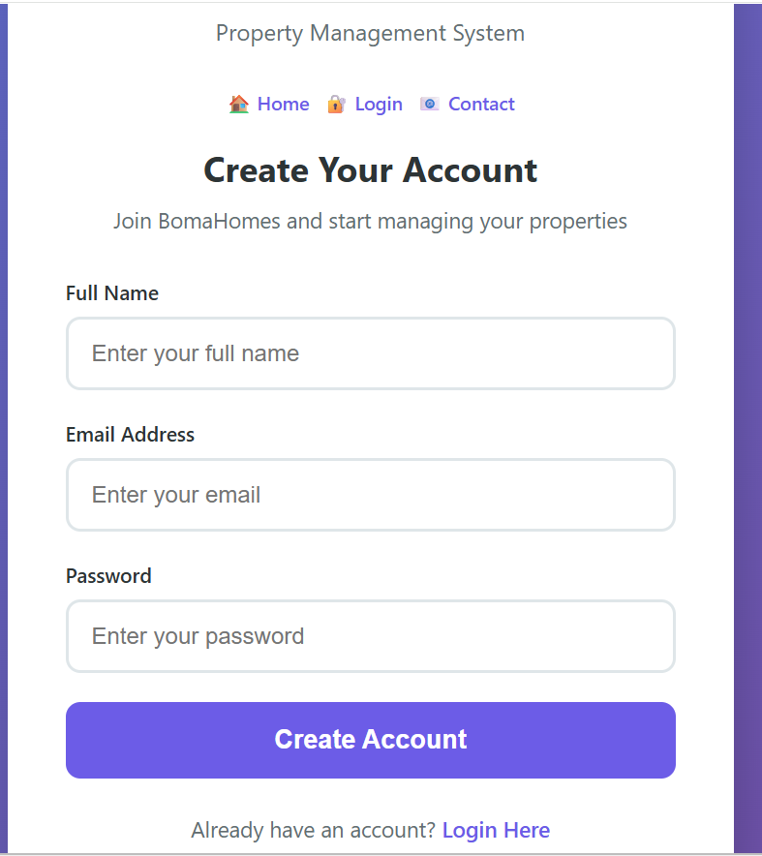

Fig 2: login form
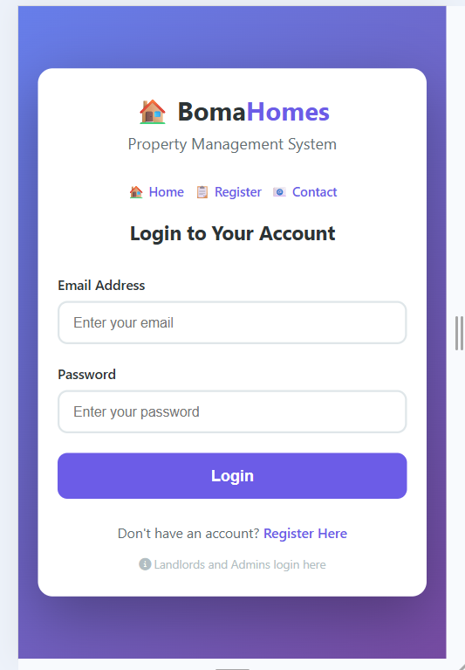

Fig 3: session handling
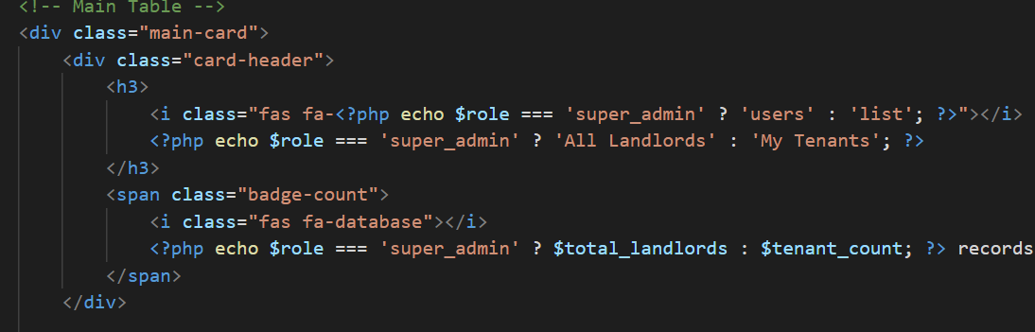

Fig 4: logout functionality
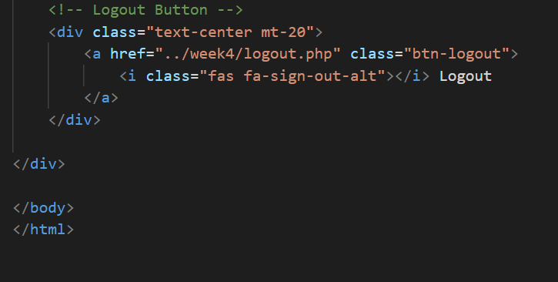

Fig 5: folder structure
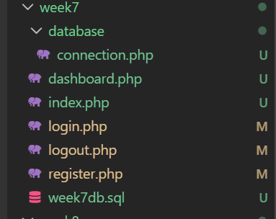

Week 8 Responsive Web Design and Mobile-First Development

Student reflection
This week I learned how to make websites work on all devices using responsive design. I added the viewport meta tag to control layout on mobile, used media queries to apply different styles at different screen sizes, and used Flexbox and CSS Grid to create flexible layouts. I made my dashboard, login, register, and contact pages responsive using a mobile-first approach. I tested my site on different screen sizes using Chrome DevTools.

Figures

Fig 1: Viewport Meta tag

Fig 2: Media Queries
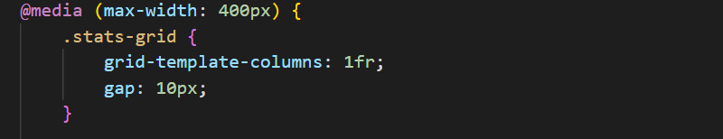
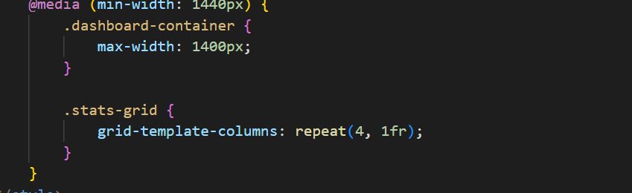

Fig 3: Flexbox layout
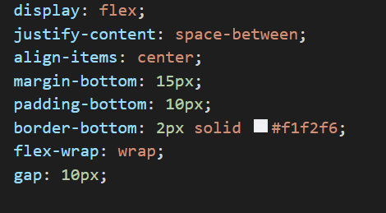

Fig 4: CSS Grid layout
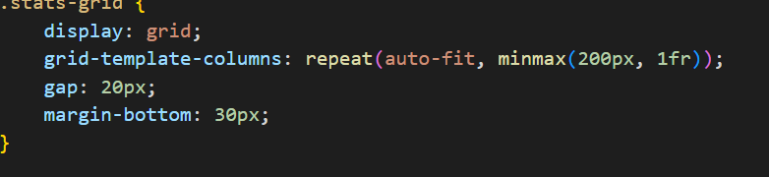

Fig 5: Responsive Dashboard
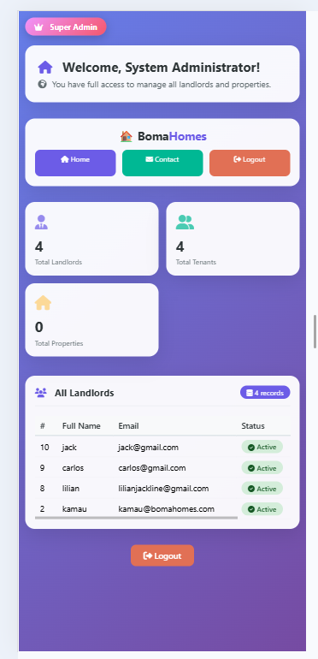

Fig 6: Responsive Register page
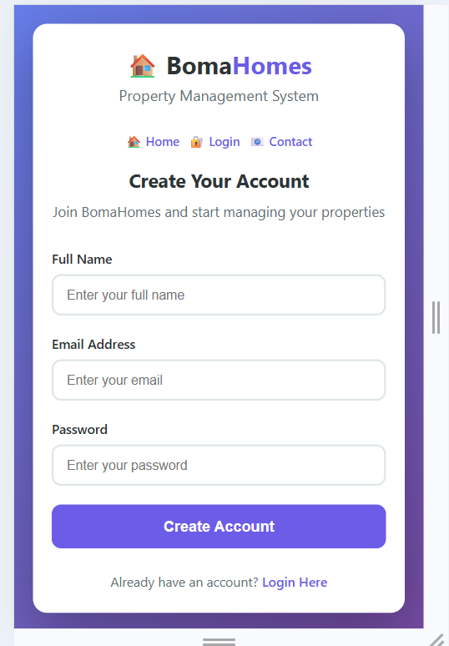

Fig 7: Responsive login page

Fig 8: folder structure
